**TASK MANAGEMENT SYSTEM**

**Project Abstract**

**Names: Sec: 1**Nandini Nagar (2320030397)

R. Akhilesh (2320030369)  
Lahari (2320030306)

**"Task-Flow: A Comprehensive Task Management System"**

**Abstract:**

Managing tasks efficiently is a common challenge for individuals and teams. People often struggle to organize tasks, keep track of deadlines, and prioritize work effectively. This can lead to missed deadlines, poor productivity, and confusion when handling multiple tasks or projects.

Many existing task management tools are either too complicated or lack essential features such as deadline reminders, task grouping, and easy prioritization. Users need a simple yet powerful solution to plan, organize, and track tasks without unnecessary complexity.

This project aims to develop a user-friendly task management system that allows users to create tasks, set deadlines, assign priority levels, and organize tasks into groups. With features like deadline notifications and a clean, interactive dashboard, the system will help users stay on top of their work and improve productivity.

**Dataset:**

https://drive.google.com/drive/folders/11fmtOkinZRsGH3V-XnAFWkRvk6IE9v_8?usp=sharing

**Algorithm:**

**Step 1**: Data Preparation Organize task details into a structured format (like a list or simple database), and create a small set of example tasks with categories/priorities for basic AI.

**Step 2**: Feature Extraction: Isolate key words from task descriptions to enable simple AI categorization and priority suggestions

**Step 3**: Visualization and Interpretation**:** Display task lists clearly and use simple charts or tables to show task status or priority distributions.

**Step 4**: Validation and Experimental Confirmation**:** Test the system by adding, viewing, and completing tasks, and refine the AI suggestions based on how well they match user expectations.  
Validate using user feedback and experimental testing (e.g., A/B testing).

**Step 9**: Iterative Refinement: Throughout all stages, continuously improve the system by testing, gathering feedback, and adjusting.

**Expected Outcome:**

The Project will feature an intuitive user interface with an interactive dashboard that offers a clear view of tasks, deadlines, and categories. Users will be able to assign tasks high, medium, or low priority, ensuring they focus on what's most important. Notifications and alerts will remind users of approaching deadlines, reducing the risk of overlooked tasks.

The system will also support task grouping, allowing users to organize related tasks into specific categories, such as projects or departments, to enhance clarity and collaboration. Designed with scalability and flexibility in mind, the project will leverage modern web technologies and best development practices to ensure a seamless experience across devices.

By offering these features in a user-friendly and visually appealing interface, this task management system aims to empower users to take control of their tasks, meet deadlines, and enhance overall productivity.

POSTER TASK MANAGEMENT:  
  
  
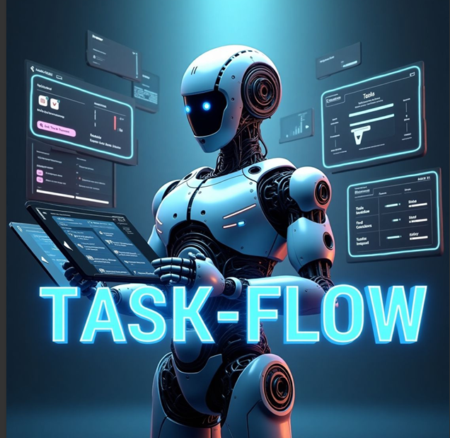

BASE RESEARCH PAPER:  
<https://drive.google.com/drive/folders/11fmtOkinZRsGH3V-XnAFWkRvk6IE9v_8?usp=sharing>  
  
  
Task Management System - Client Meeting Q&A Report

Project: Task Management System

**Meeting 1: Requirements Gathering  
  
Client Name: Nihar  
  
Client Occupation: Student  
  
**

1. What are the main pain points you're currently facing with task management?

Answer: We often forget tasks or miss deadlines because there’s no proper system.

2. Who are the primary users of this system (e.g., teams, managers, departments)?

Answer: Mostly our team leads and members who work on daily tasks.

3. What kind of tasks do you typically manage in your organization?

Answer: We handle project work, team tasks, and sometimes quick one-time jobs.

4. How do you prioritize tasks (e.g., deadlines, importance, urgency)?

Answer: Right now, we just talk or text about what’s important first.

5. Would you like this system to support both individual and team tasks?

Answer: Yes, we need it for personal task tracking and team collaboration.

6. How do you currently track task progress?

Answer: We usually ask around or use WhatsApp messages.

7. Do you need features like file attachments or comments in tasks?

Answer: Yes, being able to add files or notes will help a lot.

8. What platforms should the system support (web, mobile, both)?

Answer: Web is fine for now, but mobile will be useful later.

9. Do you need access control (e.g., admin, manager, user roles)?

Answer: Yes, so only certain people can edit or assign tasks.

10. What outcomes do you expect from this system once it’s implemented?

Answer: We want better task tracking, fewer delays, and better teamwork.

**Meeting 2: Feature Planning and Workflow  
  
Client Name: Balaji**

**Client Occupation: builder**

**Client Geotag Photo:**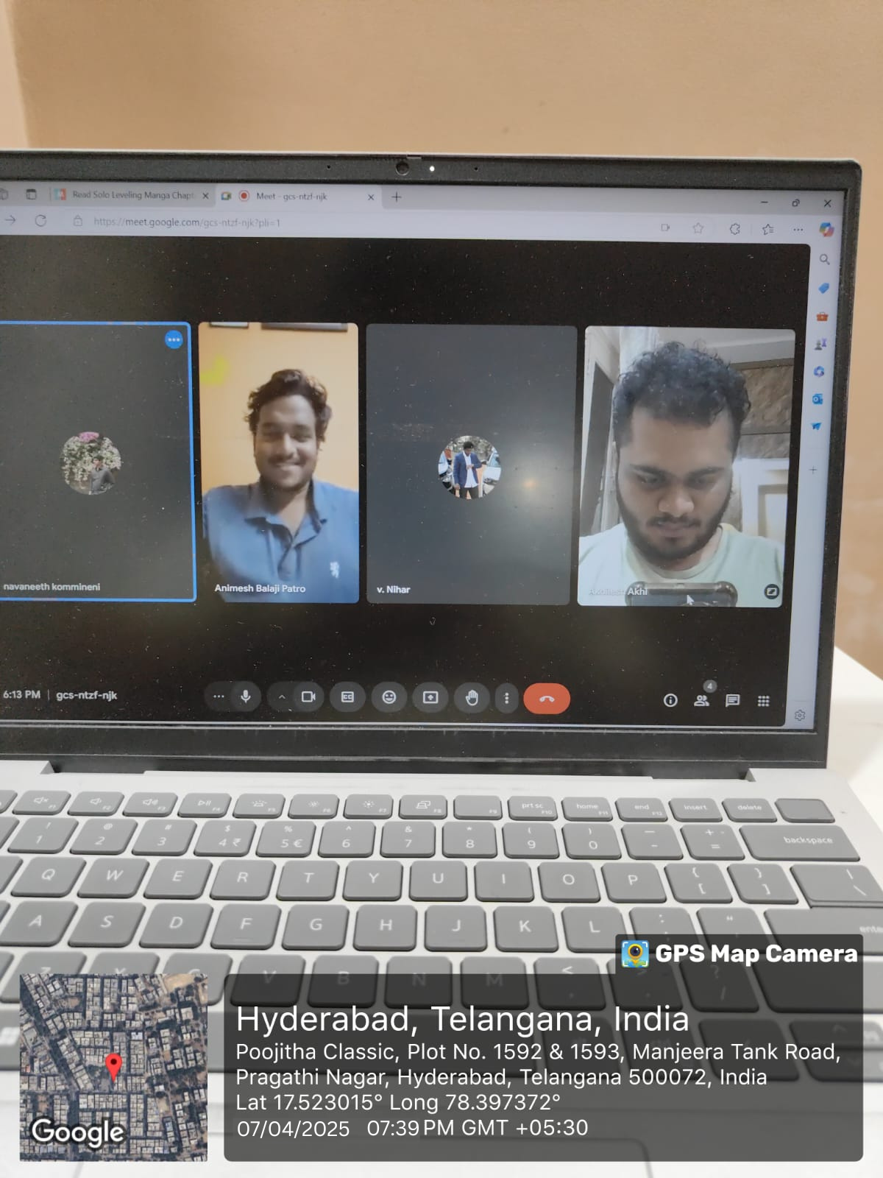

1. How should a task progress from creation to completion in your workflow?

Answer: A team lead creates a task, assigns it, the person works on it, and then marks it done.

2. Do you need task dependencies (e.g., Task B can only start after Task A)?

Answer: Yes, sometimes one task depends on another being finished first.

3. Should users receive notifications or reminders for tasks?

Answer: Yes, reminders help us stay on track.

4. How do you envision the dashboard or home screen of the system?

Answer: It should show upcoming tasks, deadlines, and progress in one place.

5. Should tasks support subtasks or checklists?

Answer: Yes, breaking big tasks into smaller parts would be helpful.

6. Do you need recurring tasks or repeating reminders?

Answer: Yes, for tasks like weekly meetings or reports.

7. What kind of filters or search features do you expect for task navigation?

Answer: We want to filter by date, priority, and team.

8. Would you like integration with email, calendar, or chat tools?

Answer: Yes, especially Google Calendar and maybe Slack later.

9. Should team members be able to comment or collaborate on a task?

Answer: Yes, that would make communication easier.

10. What kind of reporting or analytics are important to you?

Answer: Just simple reports about what’s done and what’s pending.

**Meeting 3: UI/UX and Prototype Feedback  
  
Client Name: Charan**

**Client Occupation: Business man**

**Client Geotag Photo:**

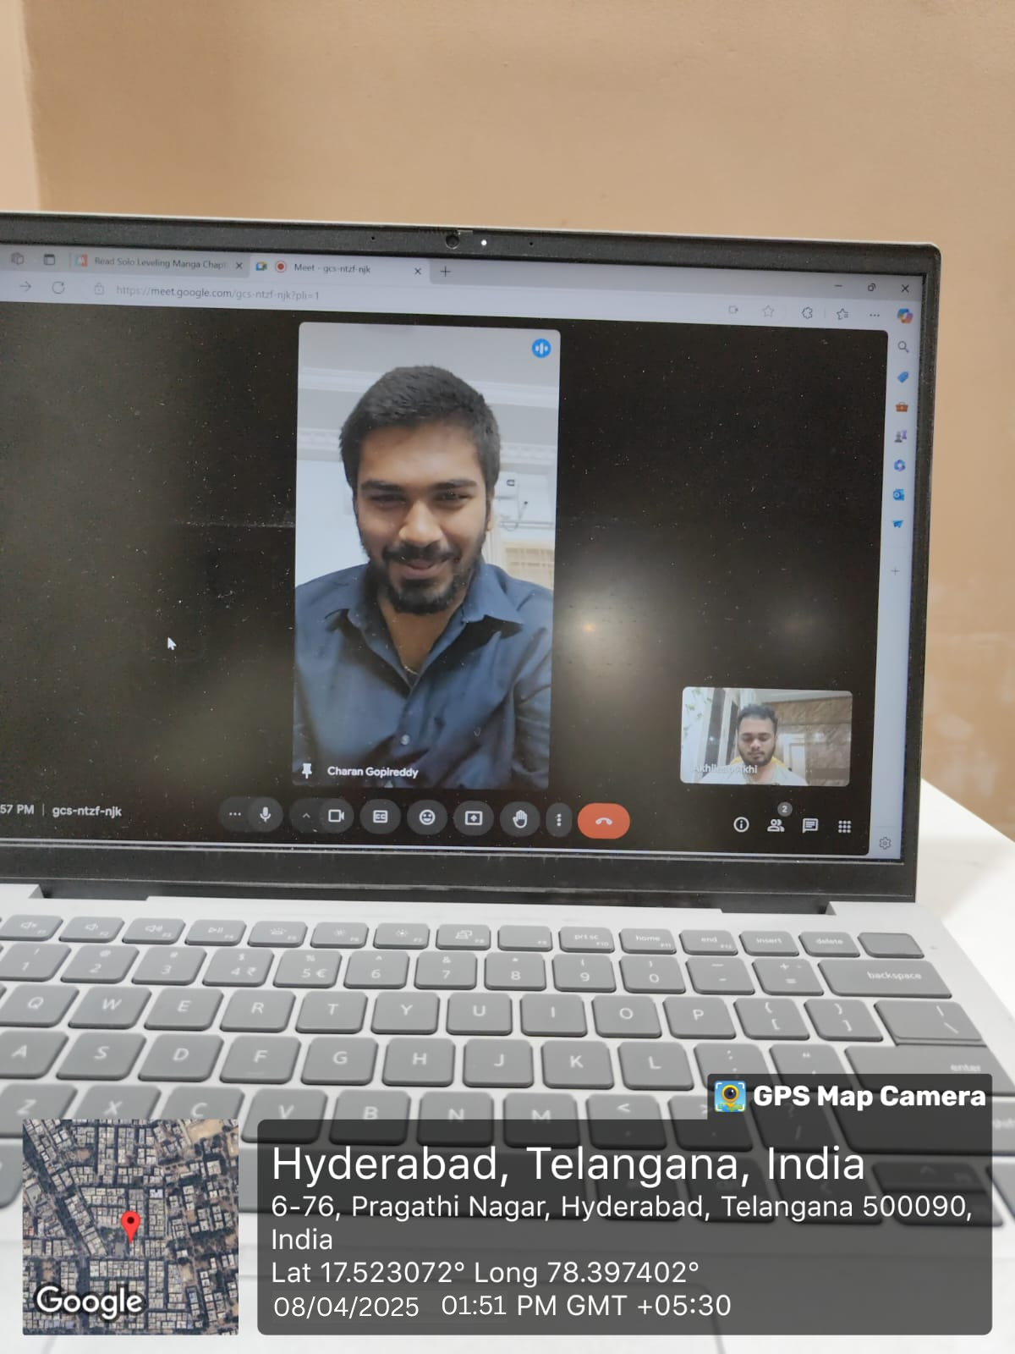

1. How do you feel about the layout and flow of the prototype so far?

Answer: It’s clean and easy to understand.

2. Are the colors, icons, and fonts appropriate for your brand and easy to read?

Answer: Yes, but maybe a bit more contrast would be nice.

3. Is the task creation form easy to use and understand?

Answer: Yes, it’s simple and straight to the point.

4. Would you like a dark mode or any accessibility options (e.g., font size, contrast)?

Answer: Dark mode would be nice for late work.

5. Are there any unnecessary steps in the current user flow?

Answer: Not really, everything seems smooth.

6. Is it easy to understand which tasks are high priority or overdue?

Answer: Yes, but a color label would help.

7. How do you feel about the mobile view or responsiveness?

Answer: We haven’t checked much, but it should be there later.

8. Would you prefer a calendar or list-based view by default?

Answer: A list view is better, but calendar is good for planning.

9. What features or buttons should be more visible or accessible?

Answer: The ‘Add Task’ button should be always visible.

10. What additional user customization would you like to see?

Answer: Letting users choose dashboard widgets would be cool.

**Meeting 4: Deployment and Final Scope Confirmation  
  
Client Name: Navaneeth**

**Client Occupation: Software Engineer**

**Client Geotag Photo:  
  
**

1. Are there any remaining features or changes you'd like to add?

Answer: No, the current plan looks good.

2. What is your preferred timeline for launch or deployment?

Answer: If we get something basic in a month, that’s perfect.

3. Do you require training or user manuals for your team?

Answer: Yes, just short guides or video tutorials would help.

4. How do you plan to onboard users to this system?

Answer: We’ll show them during a team meeting and share the manual.

5. Do you have any specific hosting or cloud provider preferences?

Answer: Not really, whatever is safe and reliable.

6. How important is it to have daily backups and data recovery features?

Answer: It’s very important in case anything goes wrong.

7. What are your security or compliance requirements?

Answer: Just make sure the data is secure and private.

8. Who will manage system maintenance and updates post-launch?

Answer: We’ll rely on the developer team for that.

9. Would you like regular reports or performance summaries sent via email?

Answer: Yes, a weekly summary would be great.

10. What are your expectations after the system is deployed (support, feedback, updates)?

Answer: We want help if bugs come up and maybe add features later.